The Right to Resist Tour for Counter Recruitment

Tour Member Biographies:

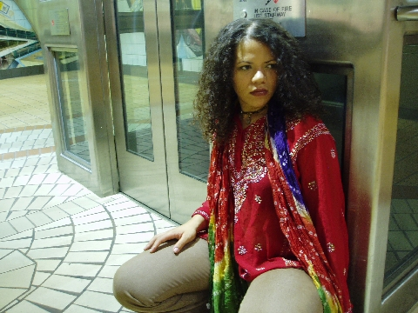
April King has been astonishing crowds around the globe with her superhuman ability to rap while drumming. Since she got her hands on the V-drums in 1998, King began her quest to bring live and improvised beats into sample and machine-based music through sound creation and electro-acoustic collaboration. Following the groove evolution of the Afrikan diaspora from drum’n’bass to funk, afro-beat to punk, house to hip-hop, rock to trip-hop, King inspires every audience to move to her transcendental grooves. King is the founder of The fReQuEnCiNg Movement which aspires to create a utopian society using musical vibrations, multicultural education, dance and organic products.

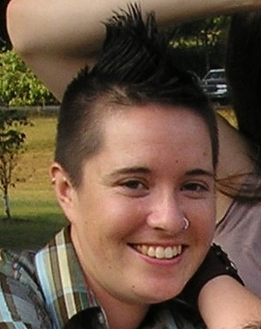
Nico Amador is a graduate of the University of California and a Freeman Fellow with FOR’s Nonviolence Youth Collective. He has worked most closely on issues related to racial and economic justice including living wage, access to education, counter recruitment and the prison industrial complex. In 2003 he helped to plan the University of California Student of Color Conference: The War on Education and the Militarization of our Community. He is a facilitator for the FOR’s Peacemaker Training Institute and a trainer with the United States Student Association’s Grassroots Organizing
Weekend Program.


Danae Davis is a graduate of Messiah College with a B.A. in American History. She is a Freeman Intern with the FOR’s Nonviolent Youth Collective and Co-Coordinator of the I Will Not Kill Campaign for Counter Recruitment. She is a facilitator with the FOR’s Peacemaker Training Institute and since the fall of 2005 has been leading workshops to get counter recruitment materials into the hands of young people.


Amanda Jack is a graduate of Boston College and a Freeman Intern with the FOR’s Task Force on Latin America. Amanda Jack has lead numerous workshops on issues ranging from “Know Your Rights” to “Labor Rights of Migrants” to “US Involvement in Latin America”. She most recently co-facilitated a workshop on Human Rights Accompaniment at the 2005 School of the Americas Watch Vigil in Ft. Benning, GA.

