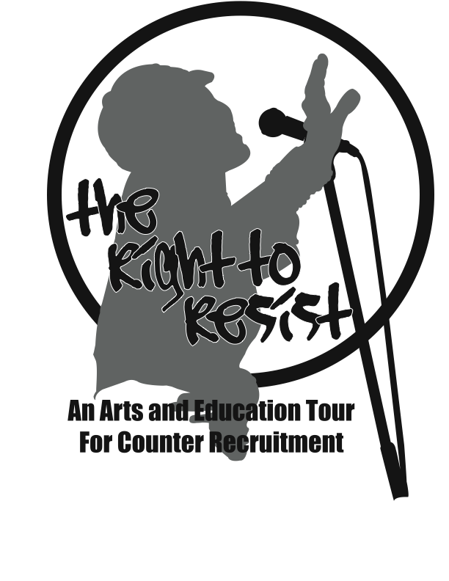
The Right to Resist Tour for Nonviolent Social Change --

an exciting opportunity for young people of all ages to learn how to mobilize for change on their campuses & in their communities…

Wednesday, April 26th
5:30pm – 8:30pm

Zacatecas Community Room
2472 University Avenue
Riverside, CA
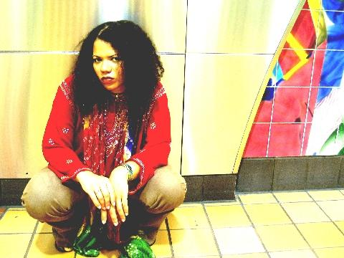

~ Spoken word and drumming with April King of the Los Angeles Frequencing Movement

~ Interactive workshop session with members of the FOR’s Nonviolent Youth Collective

~ Strategies for Nonviolent action for social change, including:
economic justice, immigration reform, counter-recruitment, international resistance to war, voter registration, creative nonviolence

Presented by the
Inland Communities Chapter of the F.O.R. (IC-FOR)
For more information: www.icfor.org or call: 951-682-5364

The Fellowship of Reconciliation is an international interfaith organization that promotes nonviolent social change. Since 1915 it has carried on projects concerned with domestic and international peace and justice issues.

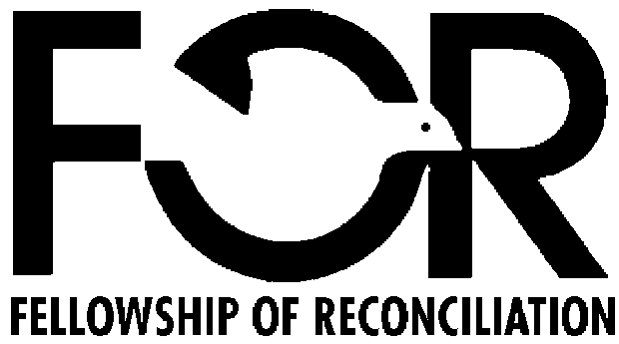 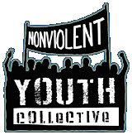 There will be GREAT FOOD!

